Day3:

======

1- class Stack: (S uppercase)

member variables(tos, size, *ptr) , (static variable "Counter") – Top of Stack

constructors(default, parameterized)

member functions: "push, pop" , (static function "getCounter")

try all class functionality (main)

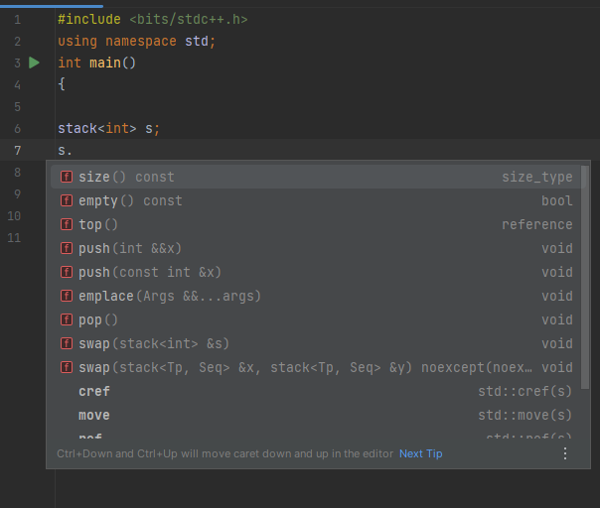

2-Function Overloading Sum

Sum (int , int)

Sum (float, float)

Sum (int , float, double)

3- Class Employee (id , name , salary) , class Department (id, name) (array of employee)

**bonus dynamically**

Push

pop

pass arr with any datA Type!